Balanced and unbalanced forces

Force diagrams can be used to show the direction and the strength of the force.

• A short arrow shows a weak force.

• A long arrow shows a strong force.

• The same force applied in opposite directions is a balanced force.

1 For each diagram below, draw an arrow showing which direction the block will travel.

|  |  |
| --- | --- |
| WS0701_00883 |  |
|  |  |

|  |  |
| --- | --- |
|  |  |
|  |  |
|  |  |
|  |  |

2 Inside each diagram box below, write whether the force is *balanced (B)* or *unbalanced (U).*

|  |  |  |  |  |  |  |  |
| --- | --- | --- | --- | --- | --- | --- | --- |
| |  |  | | --- | --- | | WS0701_00883  5N  5N | WS0701_00883  4N  3N | | WS0701_00883  2N  8N | WS0701_00883  10N  5N | | WS0701_00883  15N  15N | WS0701_00883  98N  75N | |  |
|  |  |
|  |  |

The overall net force can also be worked out by looking the length and direction of the arrows. The unit of force is measured in newtons.

• Forces acting in the same direction can be added together.

• Forces acting in opposite directions can be subtracted.

3 Under each diagram below, draw an arrow to show the direction that the block would travel and calculate the amount of force (in newtons) acting on the object.

|  |  |  |
| --- | --- | --- |
|  | WS0703_00883 | Net force = \_\_\_\_\_\_\_\_\_\_\_N |
|  | WS0703_00883 | Net force = \_\_\_\_\_\_\_\_\_\_\_N |

WORD DETECTIVE

4 Mumbo-jumbo

a Use the marked letters to find the secret word (e.g. olusntoi = solution).

b Unscramble each of the clue words below to find the message.

O

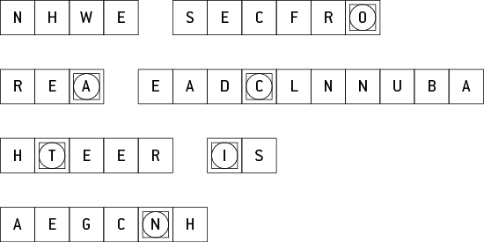

Secret word: \_\_\_\_\_\_\_\_\_\_\_\_\_\_\_\_\_\_\_\_\_\_\_\_\_\_\_\_\_\_\_\_\_\_\_\_\_\_\_\_\_\_\_\_\_\_\_\_\_\_\_\_\_\_\_\_\_\_\_\_\_\_\_\_\_\_\_\_\_\_\_\_\_\_

Message: \_\_\_\_\_\_\_\_\_\_\_\_\_\_\_\_\_\_\_\_\_\_\_\_\_\_\_\_\_\_\_\_\_\_\_\_\_\_\_\_\_\_\_\_\_\_\_\_\_\_\_\_\_\_\_\_\_\_\_\_\_\_\_\_\_\_\_\_\_\_\_\_\_\_\_\_